Create – Azure Policy Storage Directories
Assumptions
- Azure Microsoft Azure Storage Explorer is installed.
- Microsoft Azure Storage Explorer is connected to Azure Blob Storage.
Install Directions
- Go Windows Search  bar and enter Microsoft Azure Storage Explorer and click Enter key.
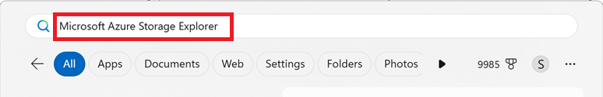
- Click Explorer button.
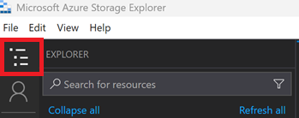
- Go to Emulator & Attached<Policy Storage Account>Blob ContainersContainer to see Blob Storage Directories if they exist.
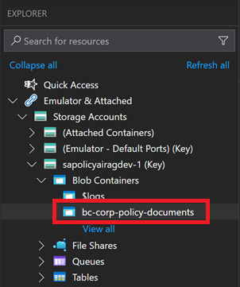
- Click New Directory menu button to create a new directory.
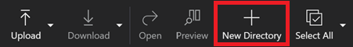
- Enter Directory Name and click OK button to create a new directory.
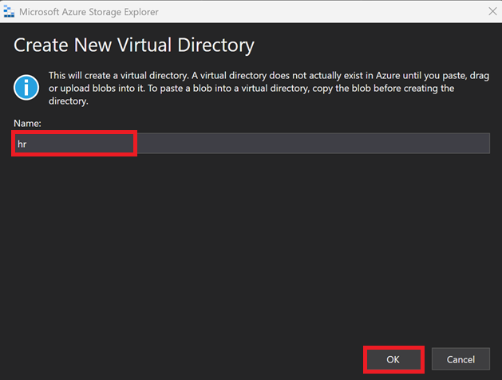
- Click Upload button to upload files to new directory. Note, Azure will not finish creating the directory if the directory does not contain any files.
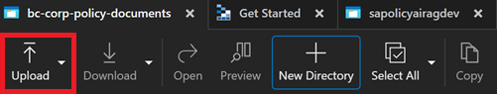
- Click Upload Files to upload HR policy files.
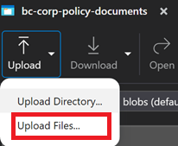

- Click Select files button to select policy folder.
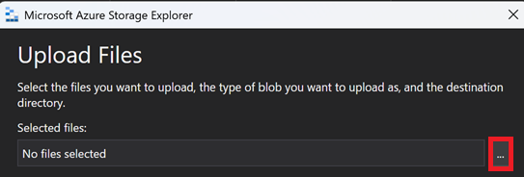
- Select the HR policy file you want to upload and click Open button.
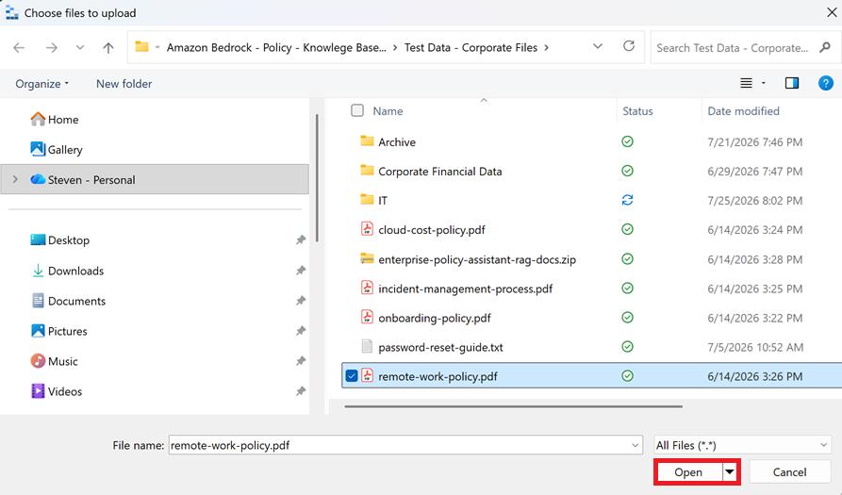
- Do the following:
- Select files to upload. In this case, HR policy file.
- Select Blob type.
- Select Target access tier.
- Select Overwrite option.
- Click Upload button.

Note: These are the default configurations.
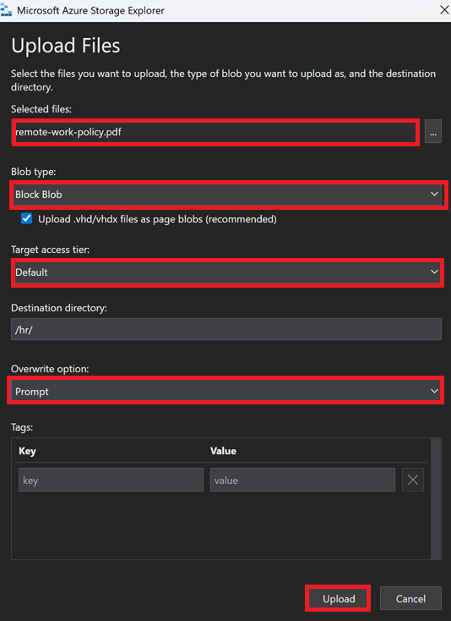
- Click New Directory menu button to create a new directory.
- Enter New Virtual Directory Name (i.e. it) and click OK button to create a new directory.
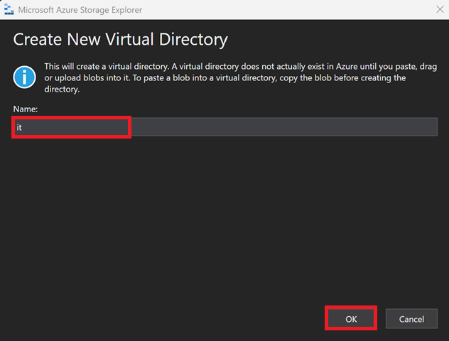
- Click Upload button to upload files to new directory. Note, Azure will not finish creating the directory if the directory does not contain any files.
- Click Upload Files to upload IT policy files.
- Click Selected files Ellipsis … button to select files to upload.
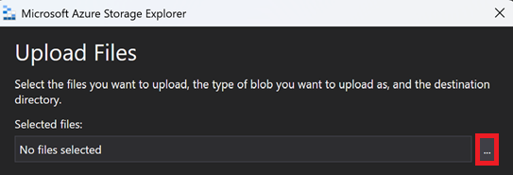
- Select IT policy file and click Open button to upload the file.
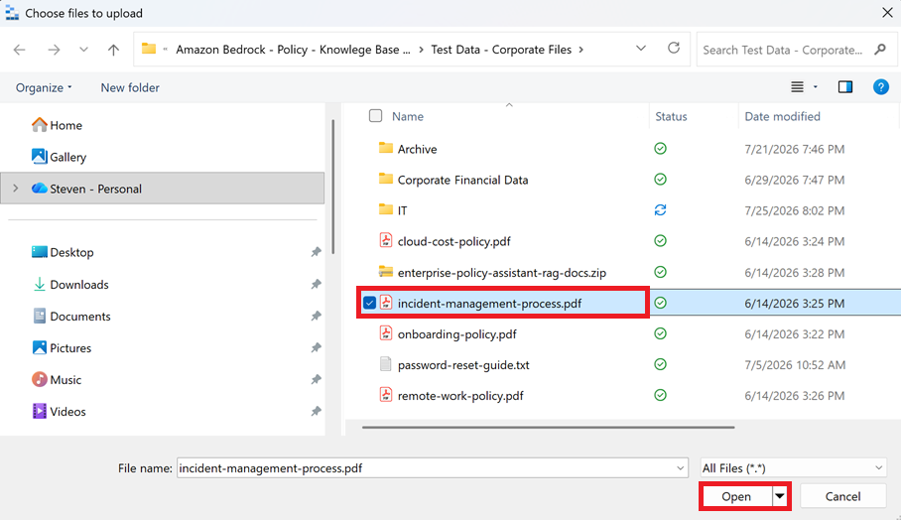
- Click Upload button to officially upload the files.

- Continue to repeat creating Directories and Uploading relevant files to those directories until your Blob Storage Container has a file structure like below:
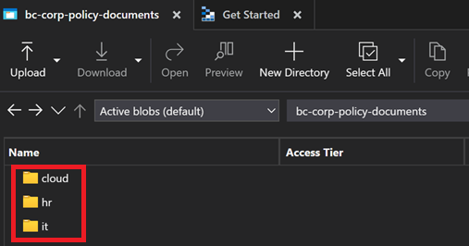
- Finished.

